# **Task 3 – Post-Mortem Report**

This document presents a detailed analysis of software requirement analysis activities conducted by Team 26. The first artifact we created during the analysis is a vision document. Following is the discussion in details:

**1.** Questions and answersfor the elicitation artefacts used in this delivery:

1. **What was the advantage of this technique based on your experience in this assignment?**

* The questionnaire was quick, efficient and cost effective to gather the basic requirements given the amount of time.
* Formulation of the questionnaire and possible answers enforces a better understanding of the problem domain through background study.

1. **What was the disadvantage of this technique based on your experience in this assignment?**

* It was difficult to narrow down the top or important questions.
* Does not provide an opportunity for clarifications and or incorporate new ideas.
* Required to have sufficient domain knowledge to come up with good questions.
* Predetermined answers to the questionnaire may have created biases for the respondents

1. **How efficient was the technique, i.e. how good requirements did it help uncover given the time it took to use?**

* This technique helped to understand the fundamental components and the working of the system. The technique enabled us to get insights about the problem world in a fairly short amount of time.

1. **In which situations would you use this technique in a future project?**

* Questionnaires can be used in simple, straight forward projects where all the stakeholders have sufficient domain knowledge. It can also be a good technique to enhance existing projects.

1. **In which situations would you not use this technique in a future project?**

* This technique cannot be used alone for complex projects; however, it can be used in combination with other elicitation techniques like interviews, prototyping etc. It may also not be suitable in projects where the stakeholders do not have sufficient domain knowledge and has vague requirements/ideas.

1. Summarize how much time was spent (in total and by each group member) on the steps/activities involved as well as for the delivery as a whole. Be honest with the time spent, as this information will in no way be used for any grading. For more details related to commit history and logging of this delivery-1, please see Appendix A to Appendix E.

|  |  |  |  |  |  |  |
| --- | --- | --- | --- | --- | --- | --- |
| Task | Sub Task | Apoorv | Divya | Manik | Nikhil | Sakib |
| Background Study | - |  |  | 30 Minutes |  | 60 Minutes |
| Elicitation Artifacts | Communication |  |  | 120 Minutes |  | 80 Minutes |
| Documentation |  |  | 180 Minutes |  | 120 minutes |
| Review |  |  | 120 Minutes |  | 60 minutes |
| Vision Document | Communication |  |  | 120 Minutes |  | 120 Minutes |
| Documentation |  |  | 120 Minutes |  | 150 Minutes |
| Review |  |  | 180 Minutes |  | 60 minutes |
| Postmortem Report | Communication |  |  | 60 Minutes |  | 40 minutes |
| Documentation |  |  | 60 Minutes |  | 30 minutes |
| Review |  |  | 60 Minutes |  | 30 minutes |

1. In addition to the material seen in class, what other techniques did you apply for completing this delivery?
2. **Which techniques worked well**

Brainstorming among the team members.

1. **Which techniques did not work?**

We tried to use google docs making draft and paper review with critiques and comments but finally use GitHub for better logging purpose. Conduct zoom meeting for peer reviews and critiques of each other works that make huge improvements.

1. How did you work together as a group in the project? What worked well, and what did not work during your interaction(s)? What would you do differently in the future?

* **Collaboration**: Used Git hub and Google Docs to collaborate the work and maintain versions. In future, Latex can be used as a collaboration tool.
* **Communication**: Zoom meetings and WhatsApp group for offline group chat. Planning to try Microsoft teams in future.
* **Reviews**: Reviews happened online during meeting. In future, planning to perform offline/individual reviews and discuss the outcome/comments during the meetings.
* **Management**: Manage time and work pupervised by group members. We use both Google drive and git together which was time wasting. In future, planning use only GitHub for saving time and logging properly.

**Appendix**

**Appendix A**

Detailed time tracking report of delivery-1:

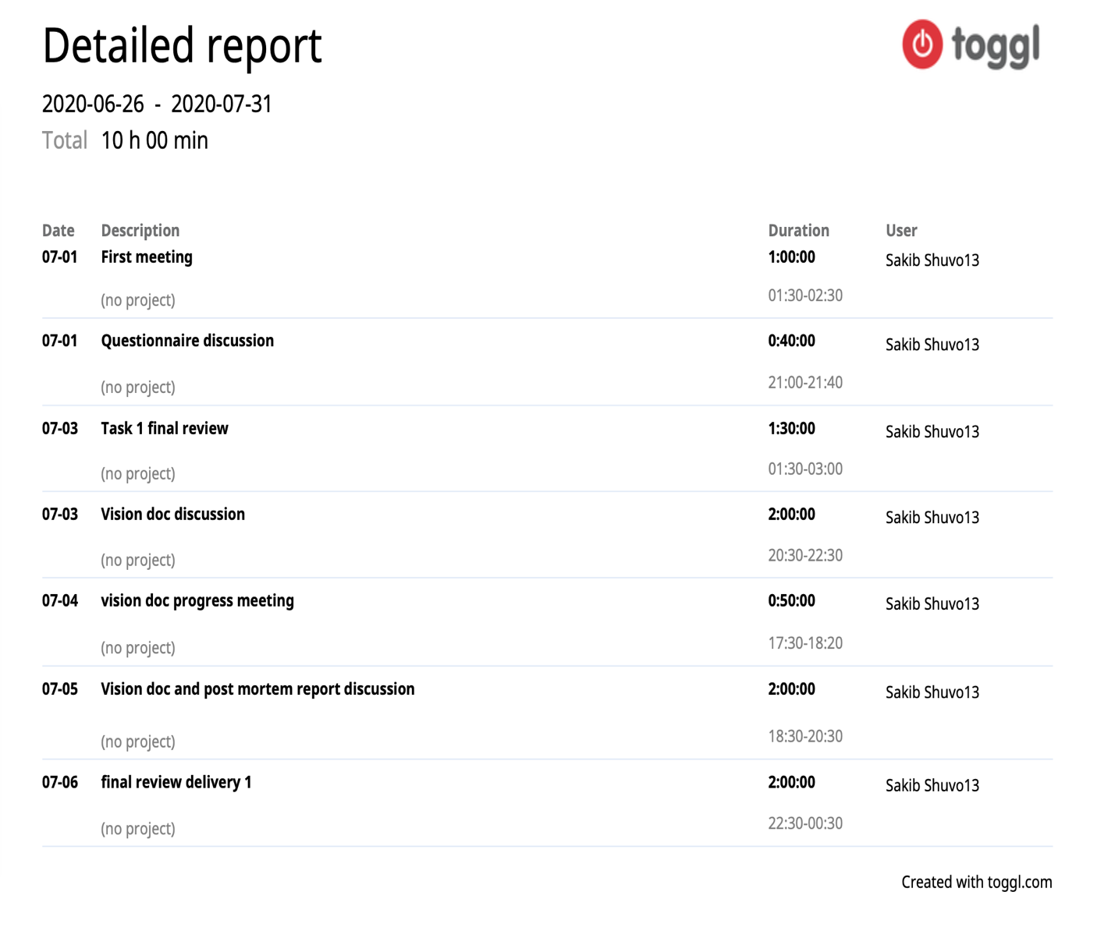

**Appendix B**

Draft vision document collaboration and peer review, discussion history on google drive: <https://docs.google.com/document/d/15c1B_ef7tt7FsPsOrMb_wkE0L4OtvFiz/edit>

**Appendix C**

Final vision document report collaboration logging history on GitHub at a glance:

<https://github.com/sakibshuvo/SOEN-6481-SRS/commits/master>

// TODO : update these picture while submit

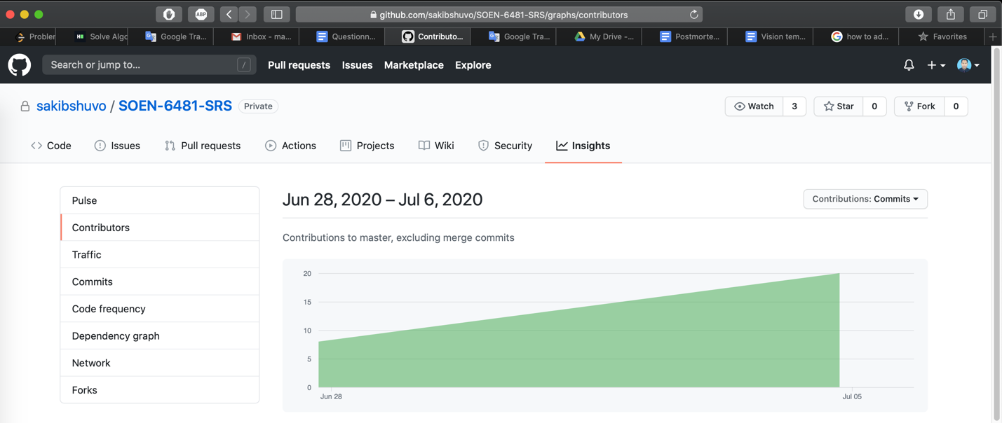

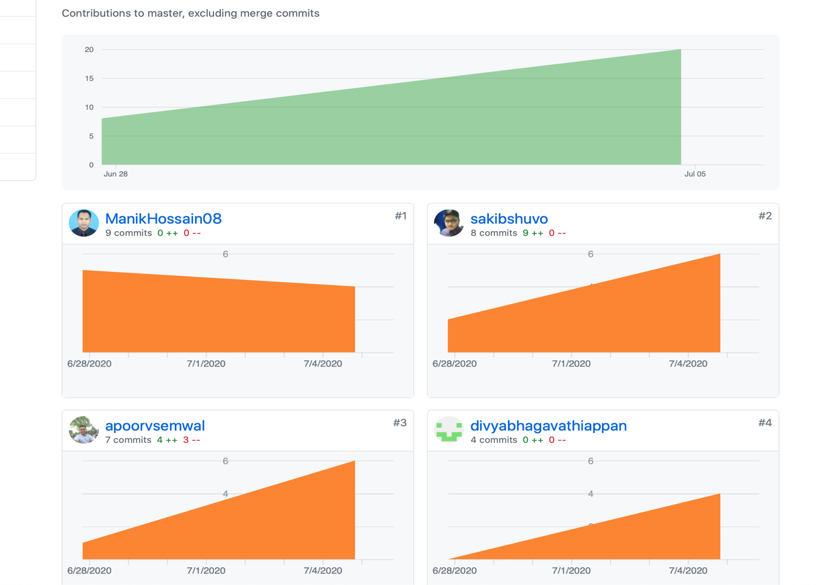

**Appendix D**

Commit history of the delivery-1 from GitHub Repo:

// Todo: update this accordingly while submit the report

**Appendix E**

Requirement elicitation for task-1 collaboration and peer review history on google drive:

<https://docs.google.com/document/d/1IljewF2ti_bijVXjqJgKjdT_azW3vl_lS0HLSR1wrS8/edit?ts=5efc0147#heading=h.7ik6ac3oskyt>